**ABC Call Volume Trend Analysis**

**Project Description:** In this project, I was experienced into the world of Customer Experience (CX) analytics, specifically focusing on the inbound calling team of a company. I was provided with a dataset that contains information about the inbound calls received by a company named ABC, which operates in the insurance sector. My task was to use this data to answer the following questions:

1. **Average Call Duration:**

What is the average duration of calls for each time bucket?

1. **Call Volume Analysis:**

Can you create a chart or graph that shows the number of calls received in each time bucket?

1. **Manpower Planning:**

What is the minimum number of agents required in each time bucket to reduce the abandon rate to 10%?

1. **Night Shift Manpower Planning:**

Propose a manpower plan for each time bucket throughout the day, keeping the maximum abandon rate at 10%.

**Approach:** First Igone through dataset to know all the columns present in the table. Then I saw all the questions and thought of functions which could be used to answer each question. After that I applied those functions and found the answer to each question and plotted the graph wherever was required.

**Link of working excel file:**

<https://docs.google.com/spreadsheets/d/1ylXt9mu_V5DmdTaMRfBrxA3ZwwkNJHnG/edit?usp=sharing&ouid=106942457558004201317&rtpof=true&sd=true>

**Tech-Stack Used:** The software used for the project is Microsoft Excel 365. It is used to run the functions and get answers of each question. It is also used to plot the graphs.

**Insights:**

1. Average Call Duration:

Function:-

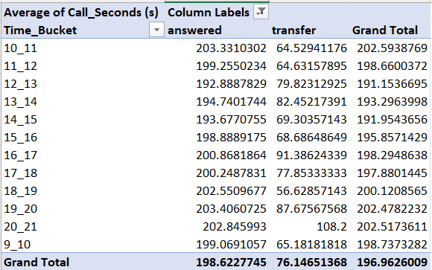

Output:-

1. Call Volume Analysis:

Function:-

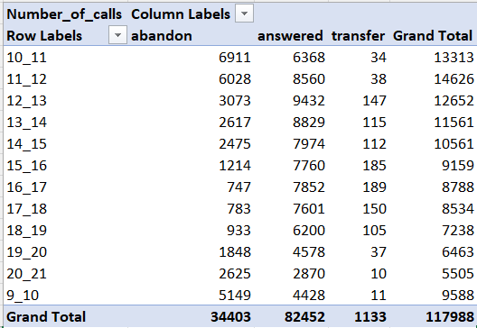

Output:-

1. Manpower Planning:

Function:-

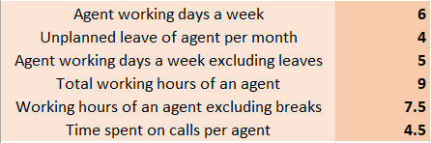

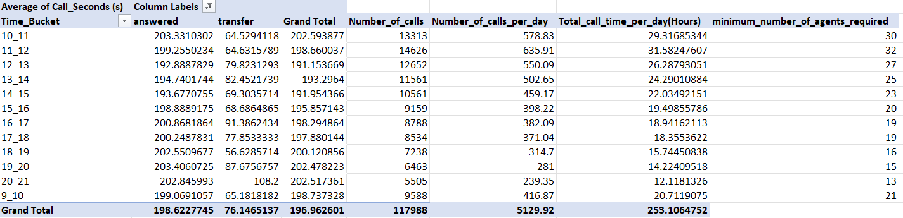

Output:-



1. Night Shift Manpower Planning:

Function:-

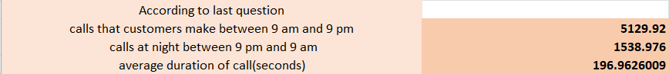

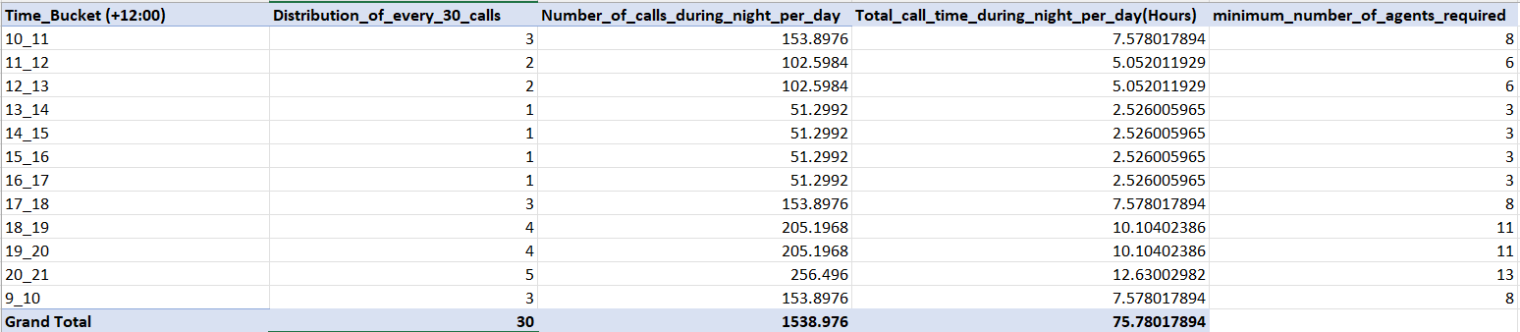

Output:-



**Dashboard:**

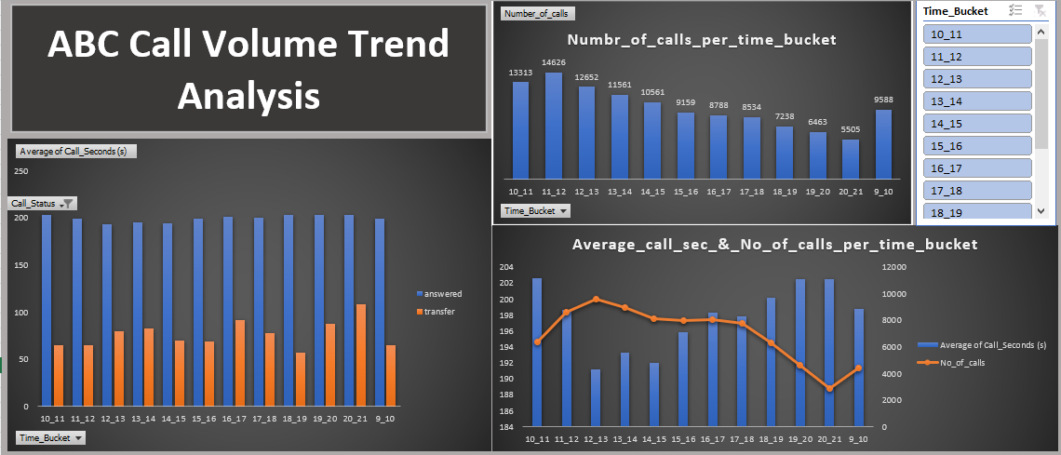

**Results:**

1. Average Call Duration:

Most call duration is of 10_11 time bucket.

1. Call Volume Analysis:

Most calls are received between 11_12 time buckets.

1. Manpower Planning:

Minimum number of agents required per day is 57.

1. Night Shift Manpower Planning:

Minimum number of agents required during night per day is 17.